Data Acquisition, Cleaning, and Preprocessing Report
New York City Airbnb Open Data (2019)
Virtual Data Science with Python Trainee — Week 1 Task

1. Introduction
This report documents the process of acquiring a publicly available dataset, exploring its structure, identifying data quality issues, and applying cleaning and preprocessing techniques using Python. The dataset used is the New York City Airbnb Open Data (2019), a widely used real-world dataset originally sourced from Kaggle. It contains approximately 48,895 listing records across 16 attributes, including host information, location, pricing, and availability, making it well suited for demonstrating data acquisition and cleaning skills on genuinely messy real-world data.

2. Data Acquisition
The dataset was obtained in CSV format and loaded into a pandas DataFrame for analysis. The source provides a snapshot of Airbnb listing activity in New York City for the year 2019, covering listing identifiers, host details, geographic coordinates, room type, nightly price, minimum stay requirements, review activity, and yearly availability.
import pandas as pd
import numpy as np
df = pd.read_csv("AB_NYC_2019.csv")
print("Shape:", df.shape)
print(df.dtypes)
print(df.isna().sum())
Initial inspection showed the dataset contains 48,895 rows and 16 columns, with a mix of numeric fields (price, latitude/longitude, minimum_nights, number_of_reviews) and categorical/text fields (neighbourhood_group, room_type, name, host_name).

3. Initial Data Exploration
Before cleaning, summary statistics and missing-value counts were generated to understand data quality. Two columns, name and host_name, had a small number of missing text entries (16 and 21 respectively). Two columns, last_review and reviews_per_month, had substantial missingness (10,052 rows each) — this is not random: it corresponds to listings that have never received a review, so 'missing' here carries meaning rather than being a defect to blindly discard.
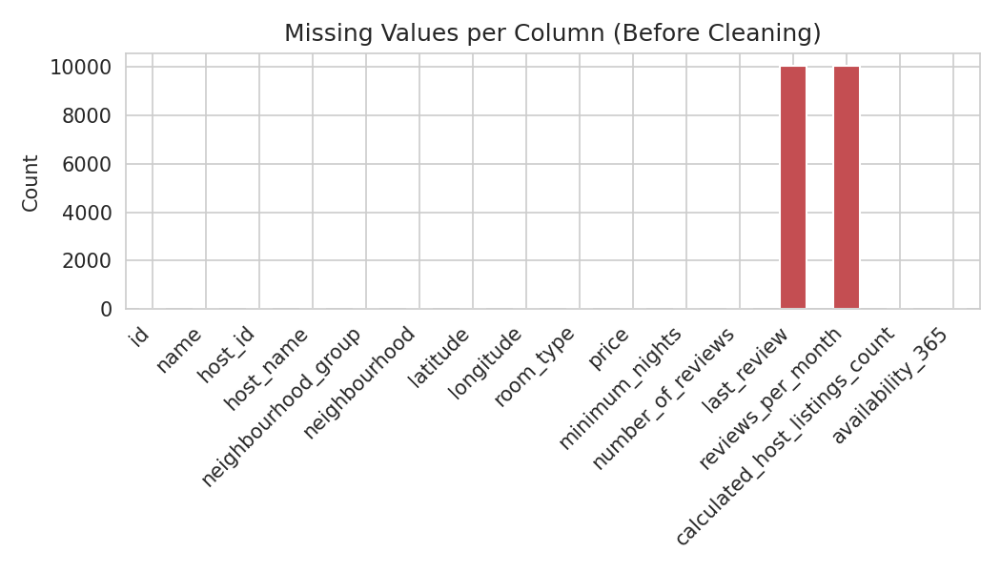
Figure 1. Missing values per column prior to cleaning.
No exact duplicate rows were found in the raw dataset. The price column ranged from $0 to over $10,000, and minimum_nights contained values as high as 1,250 nights — both signs of erroneous or extreme entries that needed further investigation.

4. Handling Missing Values
Missing values were addressed based on the nature of each column rather than a single blanket rule:
- name and host_name: the 16 and 21 missing entries were filled with the placeholder 'Unknown', since these are identifying text fields with no numeric meaning to impute.
- reviews_per_month: missing values were filled with 0, since a missing value here reliably corresponds to a listing with zero reviews (confirmed by cross-checking against number_of_reviews = 0).
- last_review: converted to a proper datetime type; remaining missing dates were left as NaT and flagged via a new boolean column, has_reviews, rather than imputed with a fabricated date, since inventing a review date would distort any time-based analysis.
df["name"] = df["name"].fillna("Unknown")
df["host_name"] = df["host_name"].fillna("Unknown")
df["reviews_per_month"] = df["reviews_per_month"].fillna(0)
df["last_review"] = pd.to_datetime(df["last_review"], errors="coerce")
df["has_reviews"] = df["last_review"].notna()

5. Identifying and Removing Duplicates
A full-row duplicate check (df.duplicated().sum()) confirmed there were zero exact duplicate rows in this dataset, so no rows were dropped at this stage. This step is still included as standard practice, since duplicate listings are a common issue in scraped or merged real-world datasets.

6. Handling Outliers and Erroneous Entries
Several data quality issues were identified and corrected:
- Zero-price listings: 11 rows had price = 0, which is not a valid Airbnb price and almost certainly reflects a data entry or scraping error. These rows were removed.
- Unrealistic minimum stays: 14 rows had minimum_nights greater than 365 (some exceeding 1,000 nights), which is inconsistent with typical short-term rental behavior. These rows were removed.
- Price outliers: using the IQR method (upper bound = Q3 + 3×IQR ≈ $493), 1,328 listings had unusually high prices. Rather than deleting these — some represent legitimate luxury listings — they were capped at the upper bound in a new price_capped column, preserving sample size while limiting the influence of extreme values on downstream analysis.
# Remove invalid prices and stays
df = df[df["price"] > 0]
df = df[df["minimum_nights"] <= 365]
# Cap extreme prices using the IQR method
Q1, Q3 = df["price"].quantile([0.25, 0.75])
IQR = Q3 - Q1
upper_bound = Q3 + 3 * IQR
df["price_capped"] = np.where(df["price"] > upper_bound, upper_bound, df["price"])
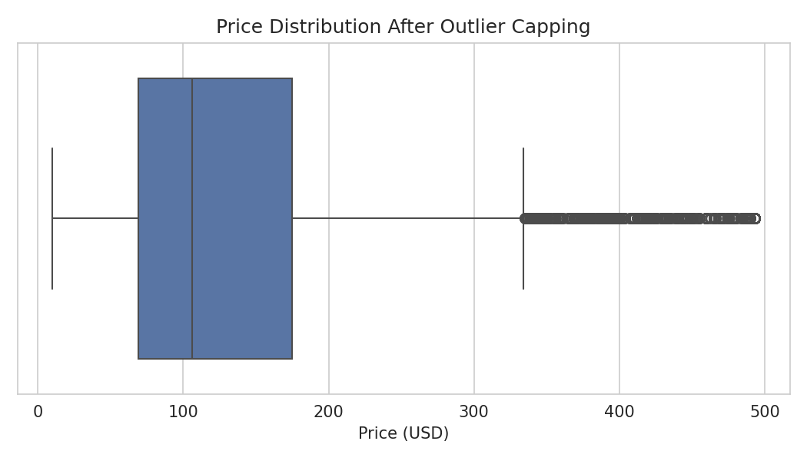
Figure 2. Price distribution after outlier capping.
After this stage, the cleaned dataset contains 48,870 rows (25 fewer than the original 48,895), with all remaining prices and stay lengths falling within plausible ranges.

7. Feature Preparation
The neighbourhood_group and room_type columns were converted to categorical dtype to reduce memory usage and make grouping operations more efficient in later analysis stages.
df["neighbourhood_group"] = df["neighbourhood_group"].astype("category")
df["room_type"] = df["room_type"].astype("category")

8. Exploratory Visualizations
With the data cleaned, a few visualizations were produced to sanity-check the result and surface early patterns.
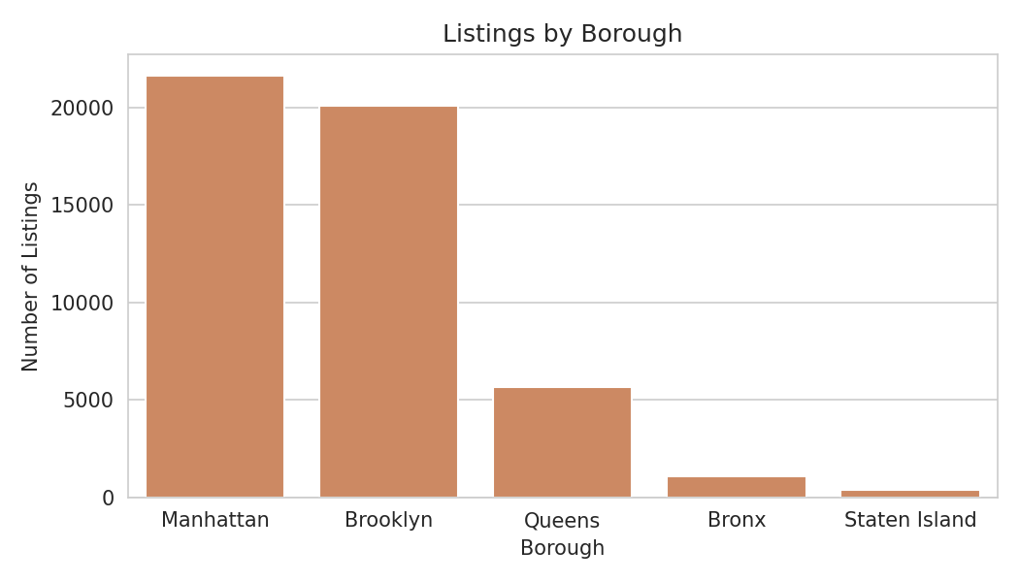
Figure 3. Number of listings by NYC borough.
Manhattan and Brooklyn account for the large majority of listings, consistent with known Airbnb activity patterns in New York City.
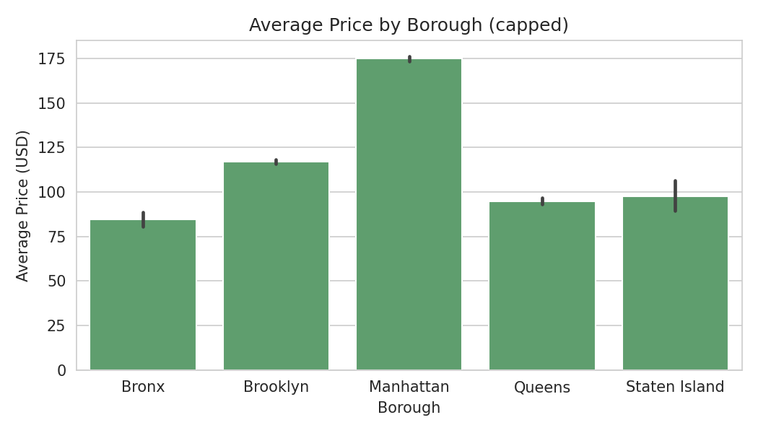
Figure 4. Average nightly price by borough (after capping).
Manhattan shows the highest average nightly price among the five boroughs, followed by Brooklyn, while the Bronx and Staten Island have the lowest average prices — a pattern that matches general real-estate cost differences across the city.

9. Discussion: Impact of Preprocessing on Further Analysis
The cleaning decisions made in this task directly shape what later analysis can and cannot say. Filling reviews_per_month with 0 rather than dropping those rows preserved roughly 20% of the dataset that would otherwise have been lost, but any model using this feature must treat 'zero reviews' and 'zero reviews per month while actively reviewed' as distinct populations, which is why the has_reviews flag was retained. Capping rather than deleting price outliers keeps the full sample size and avoids biasing borough-level or room-type averages toward only 'typical' listings, but it also means the price_capped column understates true price variance at the extreme high end — an important caveat for any pricing model built on this data. Removing zero-price and extreme-minimum-nights rows was a safe deletion (34 rows total, well under 0.1% of the data) with negligible impact on statistical power, since those values are essentially unrecoverable data entry errors rather than valid observations. Overall, prioritizing correction and flagging over blanket deletion left more usable signal in the dataset while still removing entries that would have distorted results.

10. Conclusion
This task walked through acquiring the NYC Airbnb 2019 dataset, exploring its structure, and applying targeted cleaning steps: context-aware missing value handling, a duplicate check, and outlier correction using domain-informed thresholds and the IQR method. The resulting cleaned dataset (48,870 rows, saved as AB_NYC_2019_cleaned.csv) is substantially more reliable for downstream analysis, with data quality issues either resolved or explicitly flagged for future modeling decisions.

